Application Architecture:

1. Repository Class Library.
   1. Creation of DB and inserting mock data from JSON file using Entity Framework Code First Approach.
   2. Generic Repository Pattern for data access through entity framework db context.
   3. Repository is injected to application layer with Ninject dependency resolver with Constructor Injection.
2. Profile Management MVC app.
   1. Profile management application with required use cases.
   2. ViewModels and Partial View for Create and Edit pages.
   3. Pagination in Profile List page.
   4. Search by NRIC/ Name fields (case insensitive and “like” search)
   5. Required filed validation on First Name, Last Name and NRIC.
   6. Max field length Validation applied on all Name fields and NRIC.
   7. NRIC special validation applied with Custom Attribute.
   8. Profile Activate & Deactivate function on List page.

The Application Design could be further enhanced by introducing Service layer and Repository to be injected in to Service Layer.

Service could be an Restful API service which will be hosted and consumed by at the application layer.

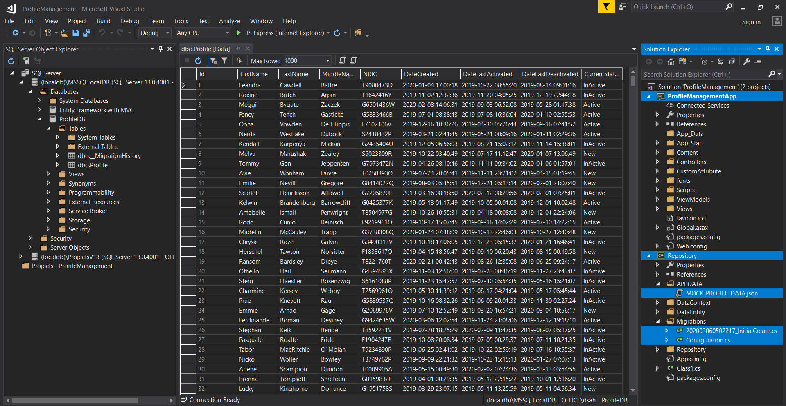

MVC App with Controller, View and ViewModels

Repository for EntityFramework Code first and Data Access

Repository Injected to Application through Ninject Dependency Injector by Constructor

Mock Json File to insert initial Records during first time by Migration Configurations

The ProfileDB created by EF Code First Migrations

Sample Application Screens:

|  |  |
| --- | --- |
| List Page (Default) |  |
| Create Profile |  |
| Update Profile |  |
|  |  |